# Tolerance resistance trade-offs as extended parasite phenotypes: Decoupling of resistance and tolerance against one of two species of *Eimeria* in mice

# Abstract

Resistance (the host’s capacity to reduce parasite burden) and tolerance (the host’s capacity to reduce impact on host health of a given parasite burden) manifest two different lines of immune defenses. Two main alternative coupling between this defense arms have been proposed: fixation of tolerance and polymorphism of resistance, or trade-off between the two. Here, we tested these scenarios in infections with two closely related parasite species of genus *Eimeria.* We measured proxies for resistance ((inverse of) number of oocysts per gram of feces at the day of maximal shedding) and tolerance (slope per host strain of maximum relative weight loss compared to day of infection on number of oocysts per gram of feces at the day of maximal shedding) in four inbred mouse strains belonging to two mouse subspecies, *Mus musculus domesticus* and *M. m. musculus*.

We found a negative correlation between resistance and tolerance against *E. falciformis*, while the two are uncoupled against *E. ferrisi*. This might be explained by intrinsic parasite components, e.g. length of life cycle and replication rate. While it is now admitted that resistance and tolerance need to be studied in conjunction, our results emphasize the importance to do so at the parasite species level.

# Introduction

Parasites are ubiquitous in natural systems, causing damages to their hosts and interacting closely with them over several generations. The incentive of the host to evolve defense tactics makes parasites a plausible selective force for their host immune system [(Schmid-Hempel, 2009)](https://www.zotero.org/google-docs/?o5QpeJ). Traditionally, a large number of studies only focused on parasites counts, an approach that does not allow to draw satisfactory conclusions on the host fitness, i.e. its ability to pass on its genes to the following generation (Råberg, Graham, & Read, 2009; Kutzer & Armitage, 2016). For example, hybrids of the house mouse subspecies *Mus musculus musculus* and *M. m. domesticus* show reduced parasite load compared to both parental subspecies (Baird et al., 2012; Balard et al., 2019). Interpretations of these results in terms of health or even fitness effects have been attempted (Sage, Heyneman, Lim, & Wilson, 1986) and criticised (Baird & Goüy de Bellocq, 2019).

Indeed, host defense mechanisms evolving in response to feedback between hosts and parasites can be categorised into two components: resistance and tolerance (Little, Shuker, Colegrave, Day, & Graham, 2010). Resistance is the ability of a host to reduce its parasite burden. It results from defense against parasite infection or proliferation early after infection (Råberg et al., 2009). A too strong immune response against parasites results in immunopathology (Graham, Allen, & Read, 2005). Disease tolerance balances damage caused by parasites themselves and immunopathology (Medzhitov, Schneider, & Soares, 2012) through control mechanisms like stress response, damage repair and cellular regeneration (Soares, Teixeira, & Moita, 2017). A relatively resistant host would not necessarily be the fittest of the population if it presents a low tolerance to parasites (Råberg et al., 2009).

The balance between costs associated with parasitism, with resistance and with tolerance determines the optimal level of both defense mechanisms (Sheldon & Verhulst, 1996). Theory predicts distinct evolution of resistance and tolerance, as they both impact parasite finess differently. According to this view, resistance alleles should present polymorphisms maintained by balancing selection, and tolerance alleles evolve to fixation (Roy & Kirchner 2000; Miller et al. 2005). Nevertheless, due to the redundancy of resistance and tolerance, they can be traded off against each other, different genotypes presenting intermediate levels of resistance and tolerance, high resistance and low tolerance, or vice versa (Restif & Koella, 2004; Fornoni, Nuñez-Farfan, Valverde, & Rausher, 2004). Such negative correlation between resistance and tolerance was found empirically e.g. in laboratory mouse strains upon infection with *Plasmodium chabaudi* (Råberg, Sim, & Read, 2007), as well as in infection of sea trout (Salmo trutta trutta) and Atlantic salmon (Salmo salar) with the trematode Diplostomum pseudospathaceum (Klemme & Karvonen, 2016). Eventually, resistance and tolerance can also be positively associated if they involve the same metabolic pathway, as was shown in the plant model *Arabidopsis thaliana* as response against herbivory(Mesa, Scholes, Juvik, & Paige, 2017) or upon infection of *Drosophila melanogaster* by the basterium *Providencia rettgeri* (Howick & Lazzaro, 2017).

Coupling between resistance and tolerance (or absence thereof) depends not only on host factors, but could also be conditionned by parasite intrinsic factors. In the present study, we tested the possiblitiy of discrepancies between resistance-tolerance coupling strategies upon infection with two closely related parasite species presenting distinct duration and intensity of replication. To that end we infected four inbred mouse strains representative of two house mouse subspecies, *M. m. domesticus* and *M. m. musculus*, with three parasite isolates representative of two naturally occuring parasite species, the protozoan parasite *Eimeria ferrisi* and *E. falciformis* (Jarquín-Díaz, Balard, Jost, et al. 2019), in a fully cross design infection. *Eimeria*spp. are monoxenous parasites that expand asexually and reproduce sexually in intestinal epithelial cells, leading to malabsorption of nutrients, tissue damage and weight loss (Chapman et al., 2013). The evolutionary history of these different *Eimeria* species in the two house mouse subspecies is unknown and it is unclear whether subspecies-specific adaptation exists in one or the other. We tested (1) if coupling between resistance and tolerance of each host differs between both parasite species; and (2) local adaptation of *E. ferrisi* using a parasite isolated in a *M. m. domesticus* host and one in a *M. m. musculus* host. We predicted that local adaptation of this parasite would translate into a higher tolerance to Western parasite of Western host (*M. m. domesticus*) than of Eastern host (*M. m. musculus*) and vice versa.

# Material and methods

## Parasite isolates

The three parasite isolates used in this study were isolated from feces of three different *M. m. domesticus/M. m. musculus* hybrid mice captured in Brandenburg, Germany, in 2016 (capture permit No. 2347/35/2014). Hybrid index (HI) of each individual wild-caught mouse was calculated to account for the admixture of mouse genomes as a proportion of *M. m. musculus* alleles in a set of 14 diagnostic markers (Balard et al., 2019). The parasite isolates belong to both the most prevalent *Eimeria* species in this area, namely *E. ferrisi* (isolates Brandenburg64 and Brandenburg139) and *E. falciformis* (isolate Brandenburg88)(Jarquín-Díaz et al., 2019). Isolate Brandenburg64 was isolated in a 92% *M. m. domesticus* individual (HI=0.08), isolate Brandenburg139 in a 85% *M. m. musculus* (HI=0.85) and isolate Brandenburg88 in a 80% *M. m. domesticus* (HI=0.2). Pre-patency and the peak day of parasite shedding for these isolates were estimated during infection in NMRI laboratory mice (Al-khlifeh et al., 2019) which were also used for serial passaging of all the isolates. Parasite infective forms (oocysts) were recovered by flotation in saturated NaCl solution followed by washing and observation under light microscope (following the protocole described in Clerc, Fenton, Babayan, & Pedersen, 2019) and stored at room temperature in 1mL of 2% potassium dichromate for a maximum of 2 months before infection of the wild-derived mouse strains. Oocysts were allowed to sporulate 10 days before infection in a water bath at 30°C.

## Mouse strains

We used four wild-derived inbred mouse strains: two representing *M. m. domesticus*: **SCHUNT** (Locality: Schweben, Hessen, Germany [N: 50° 26’, E: 9° 36’] (Martincová, Ďureje, Kreisinger, Macholán, & Piálek, 2019)) and **STRA** (Locality: Straas, Bavaria, Germany [N: 50° 11’, E: 11° 46’] (Piálek et al., 2008), and two derived from *M. m. musculus*: **BUSNA** (Locality: Buškovice, Bohemia, Czech Republic [N: 50° 14’, E: 13° 22’] (Piálek et al., 2008)) and **PWD** (Locality: Kunratice, Bohemia, Czech Republic [N: 50° 01’, E: 14° 29’] (Gregorová & Forejt, 2000))(**Figure 1**). Age of the mice at the time of infection ranged between 7.6 and 21.4 weeks. All mouse strains were maintained before infection in the Institute of Vertebrate Biology in Studenec (licence number 61974/2017‐MZE‐17214; for further details on strains see <https://housemice.cz/en>).

Parasites of the *Eimeria* genus are known to induce host immune protection against reinfection (Rose, Hesketh, & Wakelin, 1992; Smith & Hayday, 2000). To ensure that our mice were *Eimeria*-naive, mice fecal samples were tested before infection for the presence of *Eimeria* spp. oocysts, by flotation in saturated NaCl solution followed by washing and observation under light microscope.

## Experimental infection

Mice were kept in individual cages during infection. Water and food (SNIFF, Rat/Mouse maintenance feed 10 mm) were provided *ad libitum* supplemented with 1 g of sunflower and barley seeds per day. Mice were orally infected with 150 sporulated oocysts of one *Eimeria* isolate suspended in 100 µl phosphate-buffer saline (PBS) and monitored daily until their sacrifice by cervical dislocation at 11 days after infection (dpi) (experiment license Reg. 0431/17). Individuals presenting severe health deficiency and/or a weight loss approaching 18% relative to their starting weight were sacrificed earlier. Weight was recorded and feces collected on a daily basis. Fecal pellets were collected every day from each individual cage and suspended in 2% potassium dichromate. Parasite oocysts were recovered using NaCl flotation (see above).

All individuals were negative for *Eimeria* at the beginning of our experiment (before infection of first batch, as described in the next paragraph). In total, 108 mice were infected. Mice were randomly allocated to experimental groups ensuring homogeneous distribution of ages and sexes between groups. Our experiments were conducted in four consecutive batches for easy handling. The first two batches were infected by the two *E. ferrisi* isolates (Brandenburg64 and Brandenburg139), the two second by one *E. ferrisi* isolate (Brandenburg64) and one *E. falciformis* isolate (Brandenburg88). Summarised experiment design is shown in **Table 1**.

We observed *Eimeria* oocysts in the feces of 9 mice belonging to the last experimental batch at the day of infection, likely due to cross-contamination between batches. Moreover, before arrival to the infection facility, nematode eggs were observed in flotated feces of mice belonging to all genotypes. Nematode infection is common in breeding facilities (Baker, 1998). Despite treatment of the first infection batch of mice (22 mice) with anthelminthics (Profender®, Bayer AG, Levekusen, Germany) following the protocole of Mehlhorn et al. (2005), nematodes were still detected with PCR (following the protocole of Floyd, Rogers, Lambshead, & Smith, 2005) in randomly sampled fecal samples a week later. We therefore decided not to treat mice of the following infection batches. For following statistical tests, we considered the full data set and a conservative data set in which cross-contaminated animals and animals treated by anthelminthic are removed.

## Statistical analyses

### Modeling of resistance, impact of parasite on host and tolerance

As resistance is the capacity of a host to reduce its parasite burden, it is usually estimated by the inverse of infection intensity (Råberg et al., 2009). Pre-patency (the time to shedding of infectious stages, so called oocysts) is longer for *E. falciformis* (7 days) than for *E. ferrisi* (5 days) (Al-khlifeh et al., 2019). Therefore, as a proxy of resistance we used the (inverse of) number of oocysts per gram of feces (OPG) at the day of maximal shedding. We found this measurement to be tightly correlated with the sum of oocysts shed throughout the experiment (Pearson correlation coefficient 0.91). Due to the aggregation characteristic of parasites (Shaw & Dobson, [1995](https://onlinelibrary.wiley.com/doi/full/10.1111/jeb.13578" \l "jeb13578-bib-0070)), the appropriate distribution for maximum number of OPG was found to be the negative binomial distribution. This was confirmed based on log likelihood, AIC criteria and goodness-of-fits plots (density, CDF, Q-Q, P-P plots) (R packages MASS (Venables & Ripley, 2002) and fitdistrplus (Delignette-Muller & Dutang, 2015)).

Both parasite species provoke inflammation, cellular infiltration, enteric lesions, diarrhea, and ultimately weight loss (Ankrom, Chobotar, & Ernst, 1975; Ehret, Spork, Dieterich, Lucius, & Heitlinger 2017; Schito et al., 1996; Al-khlifeh et al., 2019). Therefore, the impact of parasites on host health was measured as the maximum relative weight loss compared to day 0 (body weight measured at the start of the experimental infection). Tolerance is usually defined as a reaction norm, i.e. the regression slope of host fitness (approximated by health condition) on infection intensity per genotype (Råberg et al., 2009). Therefore tolerance was assessed as the slope of maximum relative weight loss compared to day 0 on number of OPG at the day of maximal shedding, within each mouse strain and for each parasite isolate.

### Statistical design

Maximum OPG (model 1) and relative weight loss (model 2) were modelled separately as a response of mouse strain (N=4), parasite isolate (N=3) and their interaction, using a negative binomial generalised linear model for maximum OPG, and a linear model for relative weight loss. For tolerance (model 3), we performed a linear regression with null intercept (as each mouse was controlled against itself at start of the experiment, before losing weight or shedding parasite), modelling relative weight loss as a response of maximum OPG interacting with mouse strain (N=4), parasite isolate (N=3) and their interaction. To test the significance of the marginal contribution to each parameter to the full model, each parameter was removed from the full model, and the difference between full model and sub-model was assessed using likelihood ratio tests (G).

For each of our three models, if the response differed between parasite isolates (i.e. if the variable “parasite isolate” was significant), we asked within each infection group if the response differed between mouse genotypes (i.e. variable “mouse strain” significant) using likelihood ratio tests (G) as described above. Eventually, if this was the case, post-hoc multiple comparison tests (Tukey Multiple Comparisons of Means) were performed to test the significant difference in response of each host against all others (R package emmeans (Lenth, 2019)).

We verified for each analysis the absence of impact of both previous contamination by *Eimeria* and anthelminthic treatment on our results on a conservative data set excluding the 22 mice treated by anthelminthics and the 9 mice showing contaminant infections. All analyses were performed using the R software version 3.5.2 (R Development Core Team, 2018). Graphics were produced using the R package ggplot2 (Wickham, 2016) and compiled using the free software inkscape ([https://inkscape.org](https://inkscape.org/)). All codes and data used for this article can be found at: <https://github.com/alicebalard/Article_RelatedParasitesResTol>

# Results

## 1. General parasitology

The life cycle of all isolates was successfully completed in all mouse strains (**Figure 2**). For *E. ferrisi* (both isolates), the pre-patent period was 5 dpi and the median day of maximal oocyst shedding was 6 dpi (standard deviation sd=0.73 and 0.61, respectively). The median day of maximum weight loss was 5 dpi for both isolates (sd=2.1 and 1.9 respectively). For *E. falciformis* (isolate Brandenburg88) pre-patency was 7 dpi, median day of maximal shedding was 8 dpi (sd=1.2) and median day of maximal weight loss 9 dpi (sd=1.5). All tested *Eimeria* isolates infected all individuals of the tested mouse strains.

A considerable number of *M. m. musculus* mice (8/14; 5 of BUSNA and 3 of PWD) infected with *E. falciformis* (isolate Brandenburg88) died (or had to be sacrificed at humane end points specified in animal experimental procedures) before the peak of oocyst shedding. Moreover, one *M. m. domesticus* mouse (strain SCHUNT) infected by *E. ferrisi* isolate Brandenburg139 had liquid diarrhea in the peak shedding day, making its feces not collectable. These mice were assessed as missing data for both resistance and following tolerance measurements.

## **2. Resistance to *Eimeria spp.* in different mouse strains**

To establish differences of resistance between mouse strains infected by each parasite isolate, we modelled the maximum number of OPG as a measure of (inverse of) resistance (**Figure 3A**). Considering the 99 mice alive by the time of median shedding peak of each parasite isolate, we found statistically significant effects of parasite isolate (LRT: G=35.5, df=8, P<0.001), mouse strain (LRT: G=36.3, df=9, P<0.001) as well as an interaction between parasite isolate and mouse strain (LRT: G=21.8, df=6, P<0.01). This means that mouse strains are differently resistant depending on parasite isolates.

We then modelled the maximum number of OPG as a measure of (inverse of) resistance within our three infection groups, and found mouse strain significant is mice infected by *E. ferrisi* isolate Brandenburg64 (LRT: G=19, df=3, P<0.001) and *E. falciformis* isolate Brandenburg88 (LRT: G=11.6, df=6, P<0.01). For these two infection groups, we performed post-hoc multiple comparison tests.

Within mice infected by *E. ferrisi* isolate Brandenburg64, SCHUNT (*M. m. domesticus*) mice were more resistant (shedding less OPG) than both *M. m. musculus* strains (Tukey test: SCHUNT-BUSNA: P<0.01; SCHUNT-PWD: P<0.001; predicted average million OPG shed at peak and 95%CI: SCHUNT (*M. m. domesticus*): 0.5 [0.3, 0.6]; STRA (*M. m. domesticus*): 0.8 [0.6, 1.2]; BUSNA (*M. m. musculus*): 1.1 [0.8, 1.6]; PWD (*M. m. musculus*): 1.6 [1.1, 2.4]). Upon infection with *E. ferrisi* isolate Brandenburg139, all mouse strains were found equally resistant (predicted average million OPG shed at peak and 95%CI: SCHUNT: 0.5 [0.3, 0.8]; STRA: 0.6 [0.4, 1.1]; BUSNA: 0.5 [0.3, 0.8]; PWD: 0.9 [0.5, 1.5]).

Within mice infected by *E. falciformis* (isolate Brandenburg88), one *M. m. musculus* strain (PWD) was found more resistant (shedding less OPG) than one *M. m. domesticus* strain (STRA) (Tukey test: STRA-PWD: P<0.001; predicted average million OPG shed at peak and 95%CI: SCHUNT (*M. m. domesticus*): 1.1 [0.7, 1.9]; STRA (*M. m. domesticus*): 2.1 [1.3, 3.4]; BUSNA (*M. m. musculus*): 1.4 [0.5, 3.5]; PWD (*M. m. musculus*): 0.4 [0.2, 0.8]). Of note, the second strain of *M. m. musculus* (BUSNA strain) was represented by only 2 animals, as 5 died before the peak of shedding, having shed few or no oocysts.

In summary, we found heterogeneity of resistance between mouse strains infected by *E. ferrisi* isolate Brandenburg64 and *E. falciformis* isolate Brandenburg88, but not *E. ferrisi* isolate Brandenburg139.

## **3. Impact on weight of *Eimeria spp.* in different mouse strains**

We then modelled the weight loss upon infection relative to day 0 as a proxy for impact on host health of the full data set (N=108) in response to mouse strain, parasite isolate, and their interaction (**Figure 3B**). We found statistically significant differences between parasite isolates (LRT: G=47.6, df=8, P<0.001), mouse strains (LRT: G=38, df=9, P<0.001) and their interaction (LRT: G=16.2, df=6, P=0.01). We then modelled the relative weight loss within our three infection groups, and found mouse strain significant is mice infected by *E. ferrisi* isolate Brandenburg64 (LRT: G=14.6, df=3, P<0.01) and *E. falciformis* isolate Brandenburg88 (LRT: G=18.3, df=3, P<0.001). For these two infection groups, we performed post-hoc multiple comparison tests.

Upon infection with *E. ferrisi* isolate Brandenburg139, all mouse strains were affected equally, losing 6 to 10% of their initial weight at maximum (predicted average relative weight loss and 95%CI: SCHUNT (*M. m. domesticus*): 8% [4% – 12%]; STRA (*M. m. domesticus*): 7% [3% – 11%]; BUSNA (*M. m. musculus*): 6% [2% – 10%]; PWD (*M. m. musculus*): 8% [4% - 12%]). When infected with the second *E. ferrisi* isolate (Brandenburg64), one *M. m. musculus* strain (PWD) lost more weight than both *M. m. domesticus* strains (Tukey test: PWD-SCHUNT: P=0.03, PWD-STRA: P<0.01; predicted relative weight loss and 95%CI: SCHUNT (*M. m. domesticus*): 5% [2% – 7%]; STRA (*M. m. domesticus*): 3% [1% – 6%]; BUSNA (*M. m. musculus*): 7% [4% – 10%]; PWD (*M. m. musculus*): 9% [6% - 12%]).

The differences in relative weight loss were found more pronounced between strains upon infection with *E. falciformis* isolate (Brandenburg88), with one *M. m. domesticus* strain (STRA) less affected by the infection than both *M. m. musculus* strains (Tukey test: STRA-BUSNA: P<0.01; STRA-PWD: P<0.01; predicted average relative weight loss and 95%CI: SCHUNT (*M. m. domesticus*): 10% [6% – 15%]; STRA (*M. m. domesticus*): 6% [2% – 10%]; BUSNA (*M. m. musculus*): 18% [14% – 21%]; PWD (*M. m. musculus*): 19% [15% - 23%]). Of note, after losing weight, an important number of *M. m. musculus* died of infection by *E. falciformis* (3 out of 7 PWD and 5 out of 7 BUSNA). Such mortality was not found in *E. ferrisi* infected animals.

Eventually, when comparing the above values of relative weight loss of each mouse strain across infection isolates, both *M. m. domesticus* strains (STRA and SCHUNT) lost on average between 3 and 10% of their starting weight for all infections. In the other hand, both *M. m. musculus* strains (BUSNA and PWD) were found more affected on average by *E. falciformis* (18-19% relative weight loss, and high mortality as described above) than by both *E. ferrisi* isolates (6 to 9% relative wight loss). These are indications than *M. m. musculus* are more affected by *E. falciformis* than by *E. ferrisi*, while *M. m. domesticus* do not show such heterogeneity.

## **4. Tolerance to *Eimeria spp.* in different mouse strains**

Using jointly the two measurements analysed previously separately, we modelled the weight loss upon infection relative to day 0 as a linear regression of maximum oocysts per gram in interaction with *Eimeria* isolate, mouse strain and interactions between the two latter, on the full data set excluding mice that died before the infection peak (N=99). We found statistically significant differences of slope between parasite isolates (LRT: G=30.2, df=8, P<0.001), mouse strains (LRT: G=30.6, df=9, P<0.001) and their interaction (LRT: G=24, df=6, P<0.001)(**Figure 4**).

Performing this model for each infection group, we found no difference of tolerance between mouse strains for both *E. ferrisi* isolates (relative average weight loss in % per million OPG and 95%CI: Brandenburg139: SCHUNT (*M. m. domesticus*): 12 [5-29], STRA (*M. m. domesticus*): 11 [4-19], BUSNA (*M. m. musculus*): 10 [1-18]; PWD (*M. m. musculus*): 7 [3-13]; Brandenburg64: SCHUNT (*M. m. domesticus*): 6 [0-12], STRA (*M. m. domesticus*): 3 [0-6]; BUSNA (*M. m. musculus*): 4 [2-6]; PWD (*M. m. musculus*): 5 [3-7]). Brandenburg64 seems better tolerated than Brandenburg139, regardless of the mouse strains.

We found different slopes between mouse strains for *E. falciformis* isolate Brandenburg88 (LRT: G=10.3, df=3, P=0.016). We performed a post-hoc multiple comparison test for this isolate, and found that PWD (*M. m. musculus*) was less tolerant than STRA (*M. m. domesticus*) (higher value of the slope of relative weight loss per OPG; Tukey test: P=0.036; relative average weight loss in % per million OPG and 95%CI: SCHUNT: 6 [2-10], STRA: 3 [0-5]; BUSNA: 9 [2-13]; PWD: 35 [22-47]). Again, the high mortality of BUSNA, the second *M. m. musculus* strain, is likely to overestimate the calculated tolerance of this mouse strain. In summary, we found indications than *M. m. musculus* are less tolerant to *E. falciformis* than *M. m. domesticus*, while such difference could not be found for *E. ferrisi* infections.

The conclusion of our three analyses (maximum OPG, relative weight loss, slope of the two) results were consistent with results obtained on the conservative data set (excluding anthelminthic treated and contaminated mice), thus we considered the influence of both confounding factors negligible.

# Discussion

In this study, we assessed resistance and tolerance to two closely related parasites, *E. ferrisi* (two isolates) and *E. falciformis* (one isolate), in four different inbred strains representative of two house mouse subspecies. We used this controlled cross infection experiment to investigate differences in coupling between resistance and tolerance of each host between two parasite species, and potential local adaptation of one parasite species, *E. ferrisi*.

Upon infection with the first parasite species (*E. falciformis*), we observed heterogeneity of resistance between mouse strains, one *M. m. musculus* being highly resistant, one *M. m. domesticus* lowly resistant, and the two others (one *M. m. domesticus*, one *M. m. musculus*) presenting intermediate resistance levels. Mouse strains belonging to *M. m. musculus* subspecies were far more affected (in terms of weight loss but also mortality) by this parasite than strains belonging to *M. m. domesticus* subspecies. We especially found one *M. m. musculus* strain to be relatively very poorly tolerant, and one *M. m. domesticus* relatively very highly tolerant. Interestingly, the strain with low tolerance was the one with high resistance, the strain with high tolerance was the one with low resistance, and the two remaining strains showed intermediate values of both resistance and tolerance. This trade-off between resistance and tolerance could be explained by intrinsic characteristics of the parasite. Indeed, *E. falciformis* has a relatively long life cycle (Al-khlifeh et al., 2019; Haberkorn, 1970). This means that parasites multiply asexually for a relative long time leading to potentially higher tissue loads and – once it starts to reproduce sexually – extremely high reproductive output in strongly impacted hosts. Therefore, tolerance of this parasite might, on the one hand, lead to prohibitively high intensities if the parasite is allowed to expand asexually and damage the tissue (Ehret et al., 2017) without enough resistance. On the other hand, immunopathology has been observed in advanced *E. falciformis* infections. For example, proinflammatory T cell mediators have been shown to decrease parasite load but increase body weight loss upon infection (Stange et al., 2012). This might lead to multiple different optima for resistance and tolerance (Råberg et al., 2007).

Instead of such more or less stable optima in the two mouse subspecies we could speculate two related alternative explanations. Firstly, *E. falciformis* could originally be a *M. m. domesticus* parasite dissipated into *M. m. musculus* territory by a spillover through the hybrid zone. As an argument against this explanation, no significant difference in *E. falciformis* prevalence at each side of the hybrid zone has be observed (unpublished data). Secondly, the *E. falciformis* isolate employed here was collected from a predominantly *M. m. domesticus* mouse (hybrid index 0.2). The isolate could hence be locally adapted to *M. m. domesticus*. Experiments with an additional *E. falciformis* isolate from *M. m. musculus* are needed to answer the question whether host subspecies adaptation can lead to tolerance in matching pairs of *E. falciformis* and mouse subspecies.

Upon infection by the second parasite species, *E. ferrisi*, we did not find such resistance-tolerance trade-off. One isolate presented heterogeneity of resistance, but homogeneous impact on host weight and tolerance in each mouse strain. The second parasite isolate showed uniform resistance, impact on weight and tolerance in each mouse strain. As we did not find indications of higher tolerance to Western parasite of Western host (*M. m. domesticus*) than of Eastern host (*M. m. musculus*) and vice versa, our hypothesis of local adaptation of *E. ferrisi* is not supported.

*E. ferrisi* commits to sexual reproduction after a relatively short time with few cycles of asexual expansion (Al-khlifeh et al., 2019; Ankrom et al., 1975). As *E. ferrisi* infections do not reach extremely high intensities with this infection strategy, high tolerance might be the optimal strategy for both house mouse subspecies. Resistance could then evolve relatively freely without any major impact of the parasite on the hosts’ health. Enhanced virulence (reduction of host fitness upon infection e.g. due to prolonged asexual replication before commitment to sexual replication and transmission) might not evolve because the low resistance of the host already allows an optimal transmission rate, especially considering the fast production of transmission stages (Anderson & May, 1982). A global optimum of high tolerance might also be the reason why no subspecies-specific adaptation of *M. m. domesticus* or *M. m. musculus* infected strains, i.e. increased tolerance of matching host-parasite pairs, could be detected in this parasite species.

We found tolerance to be decoupled from resistance against *E. ferrisi,* while the two types of responses against *E. falciformis* were negatively correlated, suggesting a trade-off between resistance and tolerance for this second parasite. Coupling between resistance and tolerance can then differ between closely related parasite species. This finding is relevant in our system: it has been shown that hybrid between *M. m. domesticus* and *M. m. musculus* are more resistant not only to *Eimeria* but also to other parasites including pinworms (Baird et al., 2012; Balard et al., 2019) but impact on tolerance could not be measured under natural conditions (Balard et al., 2019). The effect of parasites on hosts’ fitness in particular and the role they can play in the evolution of species barriers is thus still rather ambiguous. We here show that it is indispensable to measure both resistance and tolerance in *Eimeria* infections of house mice. Such measurements can be made in future laboratory experiments involving hybrid mice. Moreover, the contrast between resistance and tolerance coupling strategies in two different parasite invites future research on the relationship between infection intensity, parasite reproductive output, host health and immune response. We argue that from a parasitologist perspective resistance and tolerance of the host can be seen as extended phenotype of parasite. Careful distinction between parasite species is necessary when analysing the influence of host genetics on such phenotypes: extended parasite phenotypes could otherwise confound host differences. This distinction can largely influence our assessment of the epidemiology of infectious diseases, and our understanding of the ecology and evolution of host–parasite interactions.

# Tables

|  |  |  |  |  |
| --- | --- | --- | --- | --- |
| **Mouse** | | **Eimeria species / isolate** | | |
| **strains** | **subspecies** | ***E. ferrisi***  **Brandenburg139** | ***E. ferrisi***  **Brandenburg64** | ***E. falciformis***  **Brandenburg88** |
| SCHUNT | *M.m.domesticus* | 7 (5M / 2F) | 14 (6M / 8F) | 6 (3M / 3F) |
| STRA | *M.m.domesticus* | 6 (2M / 4F) | 15 (8M / 7F) | 7 (4M /3F) |
| BUSNA | *M.m.musculus* | 6 (2M / 4F) | 14 (8M / 6F) | 7 (3M /4F) |
| PWD | *M.m.musculus* | 6 (3M / 3F) | 13 (10M / 3F) | 7 (1M / 6F) |

**Table 1. Infection experiment design.**

# Figures

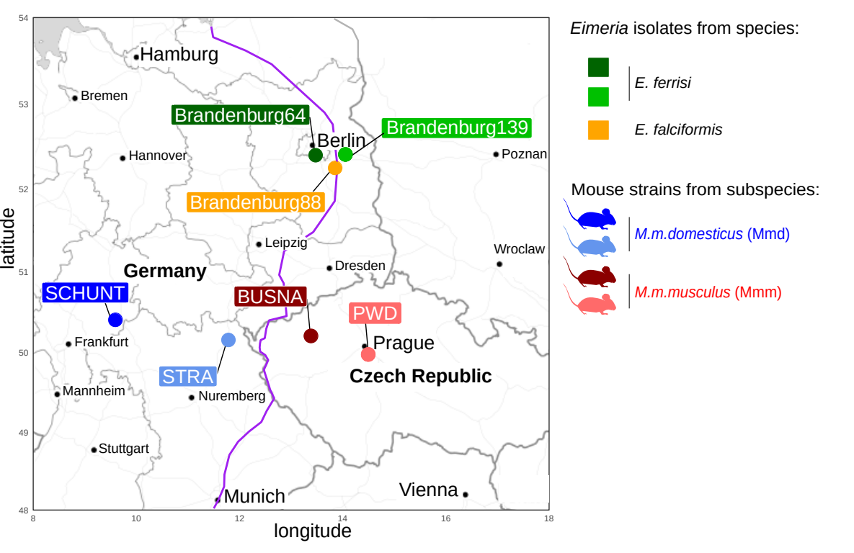**Figure 1. Parasite isolates and mouse strains.** The map shows locations at which mice were collected for breeding of mouse strains and isolation of parasites. The purple line is an estimation of the center of the house mouse hybrid zone between *M. m. domesticus* and *M. m. musculus* based on sampling and genotyping of mice in this area (Balard et al., 2019; Ďureje, Macholán, Baird, & Piálek, 2012, Macholán et al. 2019).

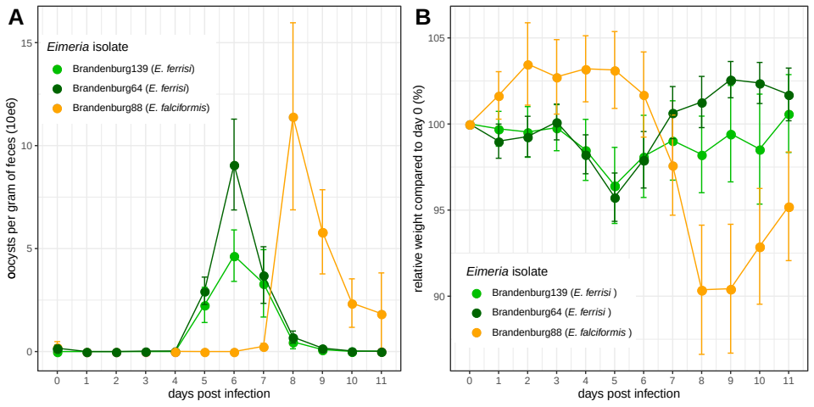

**Figure 2. Parasite density (A) and relative weight loss (B) during *Eimeria* infection.** Parasite density is calculated as number of oocysts detected (x10e6) per gram of feces, relative weight loss is calculated compared to day 0.Mean and 95% CI are plotted for each parasite isolate. All hosts strains are pooled together.

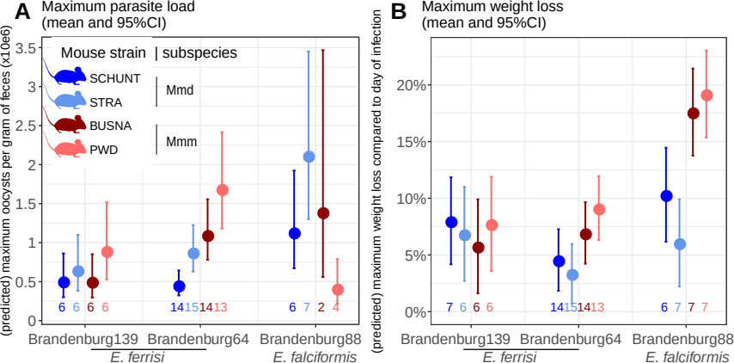**Figure 3. Predicted maximum parasite load and maximum weight loss by mouse strain and *Eimeria* isolates.** Values under bars represent the number of animals for each group. (A) Maximum oocysts per gram of feces used as a proxy for (inverse of) resistance; (B) Impact on host health measured as the maximum weight loss during patent period relative to starting weight (%)

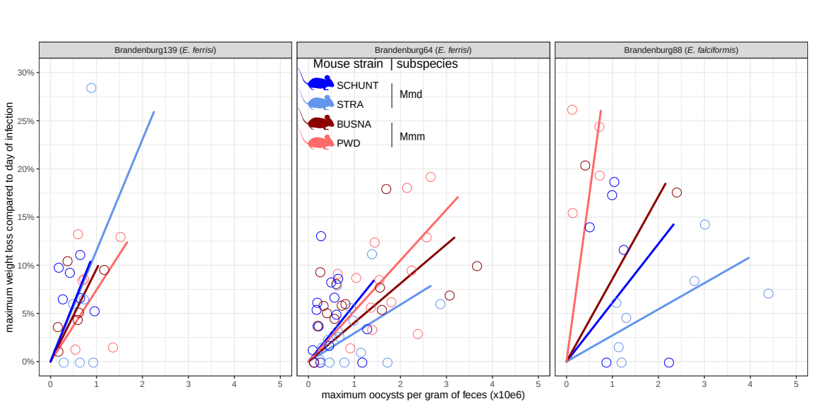**Figure 4. Predicted tolerance of each mouse strain for each *Eimeria* isolates.** Tolerance is estimated by the slope of the linear regression with null intercept modelling relative weight loss as a response of maximum oocysts per gram of feces.

# Funding

This work was funded by the German Research Foundation (DFG) Grant [HE 7320/1-1] to EH. VHJ is an associated student of GRK 2046 funded by the DFG. The maintenance of wild-derived strains was supported by the ROSE program from Czech Academy of Sciences and the Czech Science Foundation (project 16-23773S) to JP.

# References

Al-khlifeh, E., Balard, A., Jarquín-Díaz, V. H., Weyrich, A., Wibbelt, G., & Heitlinger, E. (2019). *Eimeria falciformis* BayerHaberkorn1970 and novel wild derived isolates from house mice: Differences in parasite lifecycle, pathogenicity and host immune reactions. *BioRxiv*. http://dx.doi.org/10.1101/611277

Anderson, R. M., & May, R. M. (1982). Coevolution of hosts and parasites. *Parasitology*, *85 (Pt 2)*, 411–426. https://doi.org/10.1017/s0031182000055360

Ankrom, S. L., Chobotar, B., & Ernst, J. V. (1975). Life cycle of *Eimeria ferrisi* Levine & Ivens, 1965 in the Mouse, *Mus musculus*. *The Journal of Protozoology*, *22*(3), 317–323. https://doi.org/10.1111/j.1550-7408.1975.tb05177.x

Athanasiadou, S., Tolossa, K., Debela, E., Tolera, A., & Houdijk, J. G. M. (2015). Tolerance and resistance to a nematode challenge are not always mutually exclusive. *International Journal for Parasitology*, *45*(4), 277–282. https://doi.org/10.1016/j.ijpara.2014.12.005

Baird, S. J. E., & Goüy de Bellocq, J. (2019). Shifting paradigms for studying parasitism in hybridising hosts: Response to Theodosopoulos, Hund, and Taylor. *Trends in Ecology & Evolution*, *34*, 387–389. https://doi.org/10.1016/j.tree.2019.01.011

Baird, S. J. E., Ribas, A., Macholán, M., Albrecht, T., Piálek, J., & Goüy de Bellocq, J. (2012). Where are the wormy mice? A reexamination of hybrid parasitism in the European house mouse hybrid zone. *Evolution*, *66*(9), 2757–2772. https://doi.org/10.1111/j.1558-5646.2012.01633.x

Balard, A., Jarquín-Díaz, V. H., Jost, J., Martincová, I., Ďureje, Ľ., Piálek, J., Macholán, M., Goüy de Bellocq, J., Baird, S. J. E., & Heitlinger, E. (2019). Intensity of infection with intracellular *Eimeria* spp. and pinworms is reduced in hybrid mice compared to parental subspecies. *BioRxiv*, *683698*. https://doi.org/10.1101/683698

Chapman, H. D., Barta, J. R., Blake, D., Gruber, A., Jenkins, M., Smith, N. C., Suo, X., & Tomley, F. M. (2013). Chapter two—A selective review of advances in coccidiosis research. In D. Rollinson (Ed.), *Advances in Parasitology* (Vol. 83, pp. 93–171). Academic Press. https://doi.org/10.1016/B978-0-12-407705-8.00002-1

Clerc, M., Fenton, A., Babayan, S. A., & Pedersen, A. B. (2019). Parasitic nematodes simultaneously suppress and benefit from coccidian coinfection in their natural mouse host. *Parasitology*, *146*(8), 1096–1106. https://doi.org/10.1017/S0031182019000192

Delignette-Muller, M. L., & Dutang, C. (2015). fitdistrplus: An R Package for Fitting Distributions. *Journal of Statistical Software*, *64*(4), 1–34.

Ďureje, Ľ., Macholán, M., Baird, S. J., & Piálek, J. (2012). The mouse hybrid zone in Central Europe: From morphology to molecules. *Folia Zoologica*, *61*(3–4), 308–318.

Ehret, T., Spork, S., Dieterich, C., Lucius, R., & Heitlinger, E. (2017). Dual RNA-seq reveals no plastic transcriptional response of the coccidian parasite *Eimeria falciformis* to host immune defenses. *BMC Genomics*, *18*(1), 686. https://doi.org/10.1186/s12864-017-4095-6

Floyd, R. M., Rogers, A. D., Lambshead, P. J. D., & Smith, C. R. (2005). Nematode-specific PCR primers for the 18S small subunit rRNA gene. *Molecular Ecology Notes*, *5*(3), 611–612. doi: 10.1111/j.1471-8286.2005.01009.x

Fornoni J., Nuñez-Farfan J., Valverde P.L., & Rausher M. (2004). Evolution of mixed strategies of plant defense allocation against natural enemies. Evolution. 58:1685–1695. doi:10.1554/03-510

Graham, A. L., Allen, J. E., & Read, A. F. (2005). Evolutionary causes and consequences of immunopathology. *Annual Review of Ecology, Evolution, and Systematics*, 373–397. https://doi.org/10.1146/annurev.ecolsys.36.102003.152622

Gregorová, S., & Forejt, J. (2000). PWD/Ph and PWK/Ph inbred mouse strains of *Mus m. Musculus* subspecies-a valuable resource of phenotypic variations and genomic polymorphisms. *Folia Biologica*, *46*(1), 31–41.

Haberkorn, A. (1970). Die Entwicklung von *Eimeria falciformis* (Eimer 1870) in der weißen Maus (*Mus musculus*). *Zeitschrift für Parasitenkunde*, *34*(1), 49–67. https://doi.org/10.1007/BF00629179

Howick, V. M., & Lazzaro, B. P. (2017). The genetic architecture of defence as resistance to and tolerance of bacterial infection in *Drosophila melanogaster*. *Molecular Ecology*, *26*(6), 1533–1546. doi: 10.1111/mec.14017

Jarquín-Díaz, V. H., Balard, A., Jost, J., Kraft, J., Dikmen, M. N., Kvičerová, J., & Heitlinger, E. (2019). Detection and quantification of house mouse *Eimeria* at the species level – Challenges and solutions for the assessment of coccidia in wildlife. *International Journal for Parasitology: Parasites and Wildlife*, *10*, 29–40. https://doi.org/10.1016/j.ijppaw.2019.07.004

Klemme, I., & Karvonen, A. (2016). Vertebrate defense against parasites: Interactions between avoidance, resistance, and tolerance. *Ecology and Evolution*, *7*(2), 561–571. doi: 10.1002/ece3.2645

[Kutzer, M. A. M., & Armitage, S. A. O. (2016). Maximising fitness in the face of parasites: A review of host tolerance. *Zoology*, *119*](https://www.zotero.org/google-docs/?I2LRxy)(4), 281–289. https://doi.org/10.1016/j.zool.2016.05.011

Lenth, R. (2019). emmeans: Estimated Marginal Means, aka Least-Squares Means, R package version 1.4.3.01, https://CRAN.R-project.org/package=emmeans

Little, T. J., Shuker, D. M., Colegrave, N., Day, T., & Graham, A. L. (2010). The coevolution of virulence: Tolerance in perspective. *PLOS Pathogens*, *6*(9), e1001006. https://doi.org/10.1371/journal.ppat.1001006

Macholán M., Baird S.J.E., Fornuskova A., Martincová I., Rubík, P., Ďureje Ľ., Heitlinger E., Piálek J. 2019. Widespread introgression of the *Mus musculus musculus* Y chromosome in Central Europe. *BioRxiv*. http://dx.doi.org/10.1101/2019.12.23.887471

Martincová, I., Ďureje, Ľ., Kreisinger, J., Macholán, M., & Piálek, J. (2019). Phenotypic effects of the Y chromosome are variable and structured in hybrids among house mouse recombinant lines. *Ecology and Evolution*, *9*(10), 6124–6137. https://doi.org/10.1002/ece3.5196

Medzhitov, R., Schneider, D. S., & Soares, M. P. (2012). Disease tolerance as a defense strategy. *Science*, *335*(6071), 936–941. https://doi.org/10.1126/science.1214935

Mesa, J. M., Scholes, D. R., Juvik, J. A., & Paige, K. N. (2017). Molecular constraints on resistance-tolerance trade-offs. *Ecology*, *98*(10), 2528–2537. doi: 10.1002/ecy.1948

Miller, M. R., White, A., & Boots, M. (2005). The evolution of host resistance: Tolerance and control as distinct strategies. *Journal of Theoretical Biology*, *236*(2), 198–207. https://doi.org/10.1016/j.jtbi.2005.03.005

Piálek, J., Vyskocilová, M., Bímová, B., Havelková, D., Piálková, J., Dufková, P., Bencová, V., Dureje, L., Albrecht, T., Hauffe, H. C., Macholán, M., Munclinger, P., Storchová, R., Zajícová, A., Holán, V., Gregorová, S., & Forejt, J. (2008). Development of unique house mouse resources suitable for evolutionary studies of speciation. *The Journal of Heredity*, *99*(1), 34–44. https://doi.org/10.1093/jhered/esm083

R Development Core Team. (2018). *R: A language and environment for statistical computing. R Foundation for Statistical Computing, Vienna, Austria*. http://www.R-project.org

Råberg, L., Sim, D., & Read, A. F. (2007). Disentangling genetic variation for resistance and tolerance to infectious diseases in animals. *Science*, *318*(5851), 812–814. https://doi.org/10.1126/science.1148526

Råberg, L., Graham, A. L., & Read, A. F. (2009). Decomposing health: Tolerance and resistance to parasites in animals. *Philosophical Transactions of the Royal Society B: Biological Sciences*, *364*(1513), 37–49. https://doi.org/10.1098/rstb.2008.0184

Restif, O., & Koella, J. C. (2004). Concurrent evolution of resistance and tolerance to pathogens. *The American Naturalist*, *164*(4). doi: 10.1086/423713

Rose, M. E., Hesketh, P., & Wakelin, D. (1992). Immune control of murine coccidiosis: CD4+ and CD8+ T lymphocytes contribute differentially in resistance to primary and secondary infections. *Parasitology*, *105*, 349–354. https://doi.org/10.1017/s0031182000074515

Roy, B. A., & Kirchner, J. W. (2000). Evolutionary dynamics of pathogen resistance and tolerance. *Evolution*, *54*(1), 51–63. https://doi.org/10.1111/j.0014-3820.2000.tb00007.x

Sage, R. D., Heyneman, D., Lim, K. C., & Wilson, A. C. (1986). Wormy mice in a hybrid zone. *Nature*, *324*(6092), 60–63. https://doi.org/10.1038/324060a0

Schito, M. L., Barta, J. R., & Chobotar, B. (1996). Comparison of four murine *Eimeria* species in immunocompetent and immunodeficient mice. *The Journal of Parasitology*, *82*(2), 255–262. https://doi.org/10.2307/3284157

Schmid-Hempel, P. (2009). Parasites—the new frontier: Celebrating Darwin 200. [*Biology Letters*, *5*(5), 625–627.](https://www.zotero.org/google-docs/?I2LRxy) https://doi.org/10.1098/rsbl.2009.0589

Shaw, D. J., & Dobson, A. P. (1995). Patterns of macroparasite abundance and aggregation in wildlife populations: A quantitative review.*Parasitology*, **11**(S1), S111–S127. [https://doi.org/10.1017S0031182000075855](https://doi.org/10.1017/S0031182000075855)

Sheldon, B. C., & Verhulst, S. (1996). Ecological immunology: Costly parasite defences and trade-offs in evolutionary ecology. *Trends in Ecology & Evolution*, *11*(8), 317–321. https://doi.org/10.1016/0169-5347(96)10039-2

Smith, A. L., & Hayday, A. C. (2000). Genetic dissection of primary and secondary responses to a widespread natural pathogen of the gut, *Eimeria vermiformis*. *Infection and Immunity*, *68*(11), 6273–6280. https://doi.org/10.1128/iai.68.11.6273-6280.2000

Soares, M. P., Teixeira, L., & Moita, L. F. (2017). Disease tolerance and immunity in host protection against infection. *Nature Reviews Immunology*, *17*(2), 83–96. https://doi.org/10.1038/nri.2016.136

Stange, J., Hepworth, M. R., Rausch, S., Zajic, L., Kühl, A. A., Uyttenhove, C., Renauld, J.-C., Hartmann, S., & Lucius, R. (2012). IL-22 mediates host defense against an intestinal intracellular parasite in the absence of IFN-γ at the cost of Th17-driven immunopathology. *Journal of Immunology*, *188*(5), 2410–8. https://doi.org/10.4049/jimmunol.1102062

Venables, W. N., & Ripley, B. D. (2002). *Modern Applied Statistics with S* (Fourth). Springer. http://www.stats.ox.ac.uk/pub/MASS4

Wickham, H. (2016). *ggplot2: Elegant Graphics for Data Analysis*. Springer-Verlag, New York.